Design Manual

Name: Xuhua Le

Student ID: z5047516

1. System control flow:

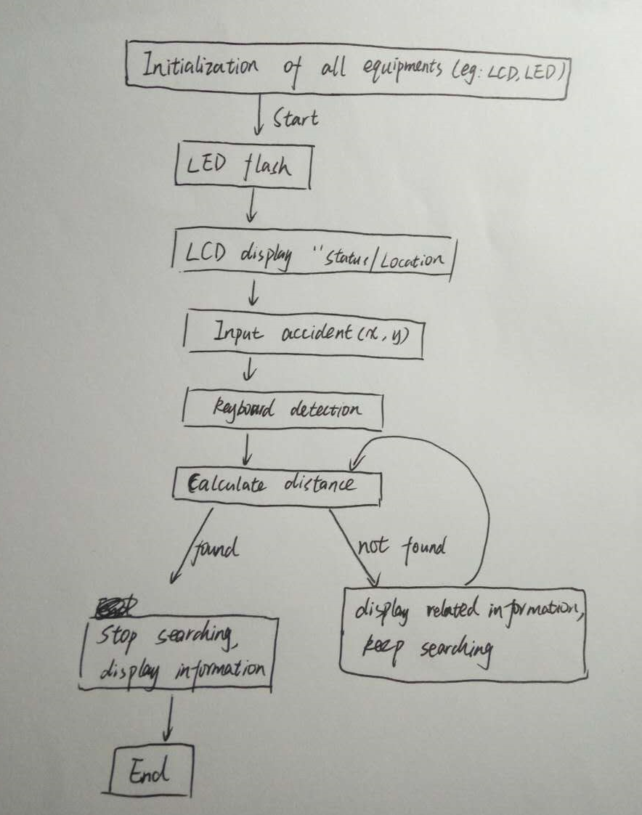

1. Data structures and algorithms used in the software design:

This project needs to build a 64\*64 map, and the height in the map needs to larger than 9 and less than 65, hence, I built a map consists of 16 mountains, I set the basic height to 10m, and the height of points grows 4m in each level in each mountain. And here is one of my mountains:

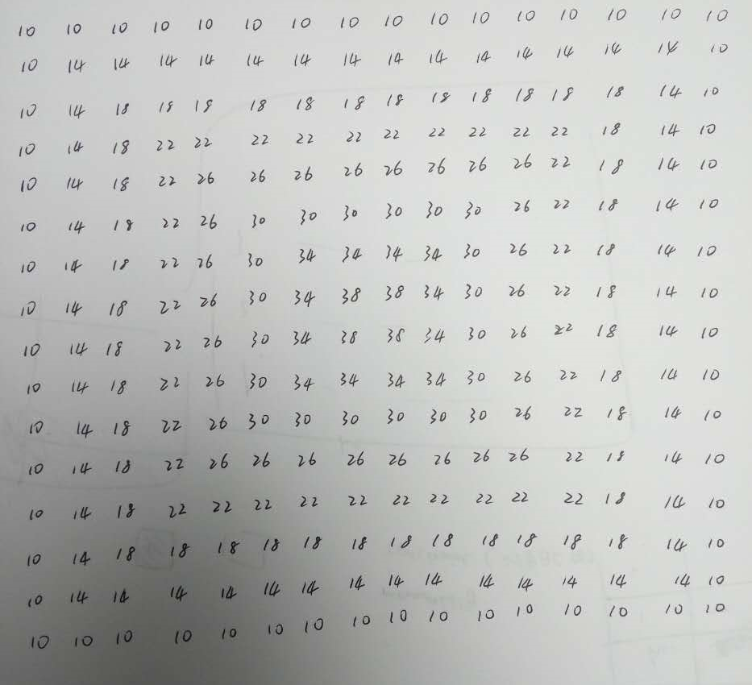

If all the heights in the map are the same, which means the map is a flat, as the drone could search a point with distance of 10m, we could divide the map into 64 same squares, and for every single square, the drone only needs to search the center of the square as the distance from the center to any other point in the square is less than 10m, and it means if the drone fly at the center, it could search all the points in the square including the accident points. According to my own map, as I have 16 same mountains and in each mountain, the heights of different positions are different, I need to take the different heights into account. But there is a similar way compared with the flat map. I could divide each mountain into 16 cube parts, hence, there are 16\*16 = 256 cubes parts in my map. In each mountain, I set one point as the searching point in each cube, hence, in a mountain, there would be 16 searching points. Following is my searching map (the numbers in the circle):

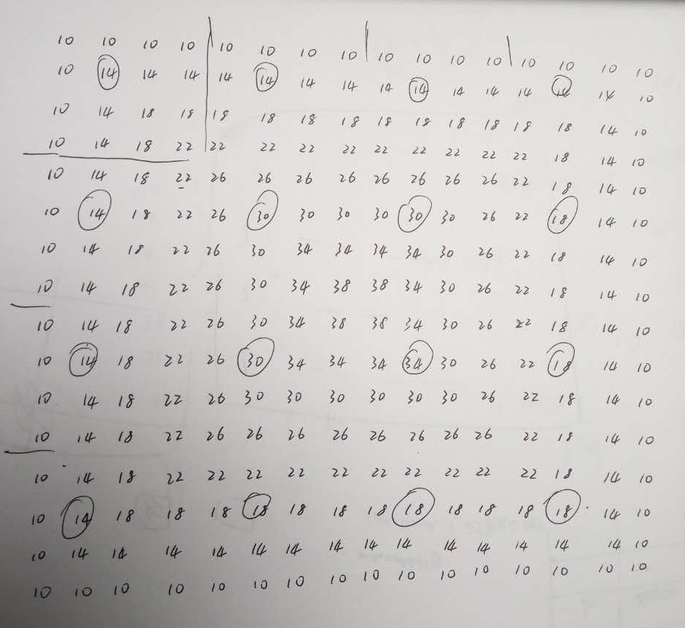

Besides, the searching points include the ridge points on the mountain, and the biggest distance from the searching point to any other points in the relative cube is sqrt(2\*2 + 2\*2 + 8\*8) = sqrt(72)m which is less than 10m, therefore, the drone could search all the points in the related cubes whether the drone is on the ridge or not. And my solution is to make the drone search the 256 searching points in my map. If the drone reaches a cube that has the accident point, the drone would stop further searching.